Nepal College of information Technology
Imado lalitpur
Assessment Exam Spring Semester 2007

Program : ELX Semester: Spring
Time : 3hrs Year : 2007
Numerical Method

1 a) Solve sinx = 1 + x³ using Newton Raphson method correct to three decimal place. 7
b) Find a root of x³ - 2x - 5 = 0 by secant method correct to two decimal place. 8
2. a) The following table gives pressure of a steam at given temperature.

Temperature °C | 140 | 150 | 160 | 170 | 180
Presure, kgf/cm² | 3.68 | 4.85 | 6.3 | 8.0 | 10.2

find pressure when temperature = 142⁰ C and 185⁰ C. 8
b) Determine a and b so that y = ae^{bx} best fits the following data 7

x: | 1 | 2 | 3 | 4
y: | 7 | 11 | 17 | 27

3. a) Fit a second degree curve to the following data:

x: | 1 | 2 | 3 | 4 | 5
y: | 3.1 | 3.7 | 6.9 | 12.6 | 20.9
by method of least squares 7
b) Evaluate 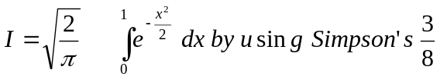 rule and Trapezoid rule. 8
4. a) Evaluate 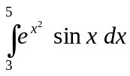 by using three-term Gaussian formula. 7
b) Evaluate 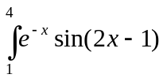by using Romberg's method 8
5. a) Solve the following system of equation by Gauss Elimination method 8
x + 2y + z - w = - 2
x + y +3z- 2w = -6
2x +3y - z - z + 2w = 7
x + y + z + w =2
b) By Gauss-seidal method , solve: 7
4x₁ + x₂ + 2x₃ = 4
3x₁ +5x₂ + x₃ = 7
x₁ + x₂ + 3x₃ = 3
6. a) By matrix factorization method solve the following system of equation: 8
x + y + z = 3
2x -y + 3z =16
3x +y - z = -3
b) Solve x³ -3x -5 =0 by fixed point iteration method. 7
7. Write short notes on (Any two) 5*2
a) Numerical differentiation
b) Convergence of fixed point iteration method
c) Write algorithm of lagrange interpolating polynomial to evaluate the value of the function at a given point.

